The Environmental Neuro-Immune Axis in Motor Neuron Degeneration: Framing ALS within the Mast Cell, Vagal Atrophy, and Toxicological Framework

───

Abstract
This paper extends the environmental neuro-immune model by examining the pathophysiology of Amyotrophic Lateral Sclerosis (ALS). While historically viewed through a strict, intrinsic motor-centric lens, contemporary research repositions ALS as a non-cell-autonomous disease heavily mediated by chronic peripheral inflammation. Specifically, this paper models how industrial food and

agricultural neurotoxins induce systemic mast cell activation and a measurable bilateral atrophy of the vagus nerve. The loss of vagal parasympathetic control uncaps peripheral immune cells, allowing c-Kit+ mast cells to migrate into the spinal cord parenchyma, degranulate along motor nerve terminals, and accelerate Wallerian degeneration. Ultimately, this places ALS at the terminal end of the environmental toxification spectrum, reinforcing the clinical imperative to address upstream environmental and autonomic stability. [6]

───

The Pathological Mechanism: Vagal Atrophy and Spinal Mast Cell Infiltration
In our prior analysis of IBS and MS, mast cell activation along the gut-brain axis causes

visceral distress and blood-brain barrier degradation. In ALS, this exact same neuro-immune axis targets the neuromuscular compartment and spinal cord. [2, 3]
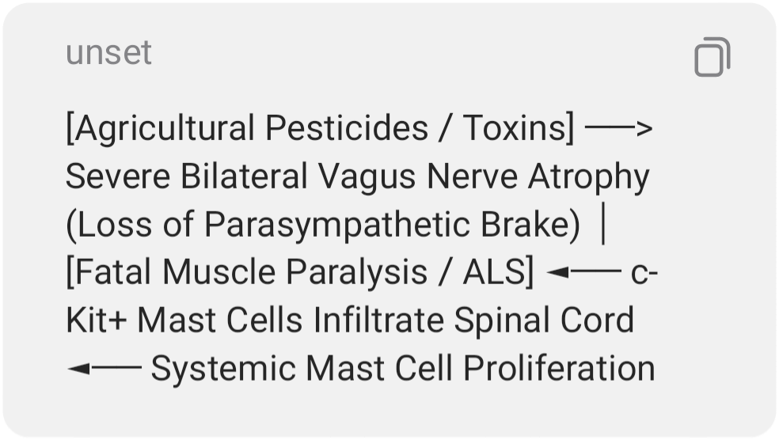
Recent neurological imaging and post-mortem studies have revealed two definitive markers that tie ALS directly into our established model:
1. Direct Vagal Nerve Atrophy
High-resolution ultrasound and morphometric studies have confirmed that patients with ALS exhibit a statistically significant, bilateral

reduction in the cross-sectional area (atrophy) of the vagus nerve. This structural degradation of the vagus nerve strips the body of its primary parasympathetic pathway. Without the vagus nerve releasing acetylcholine to suppress immune activity, the body loses its innate "cholinergic brake," throwing the patient into a permanent, highly destructive state of systemic sympathetic hyperactivity and neuro-inflammation. [1, 6, 7, 8, 9]
2. c-Kit+ Mast Cell Infiltration
Without the vagal brake to keep them quiet, mast cells proliferate uncontrollably. Specialized pathological tracking has discovered that c-Kit+ mast cells actively infiltrate the spinal cord and cluster directly around degenerating motor neuron cell bodies and neuromuscular junctions in ALS patients. Once nestled against the motor neurons, these mast cells degranulate, releasing cytotoxic molecules that strip away the nerve

endings, triggering Wallerian degeneration (nerve death) and the progressive muscle paralysis classic to ALS. [2, 3, 10]

───

Environmental Food and Agricultural Drivers of ALS
Because ALS has a low purely genetic baseline (only 5–10% of cases are familial), environmental toxicological studies utilize the "exposome" concept—the cumulative lifetime exposure to toxins—to explain the disease. The industrial farming and food preservation techniques that trigger IBS and MS act as profound neurotoxic catalysts for ALS: [11, 12, 13]
1. Organophosphate and Organochlorine Pesticides

Epidemiological data heavily links geographic clusters of sporadic ALS to agricultural regions with intense pesticide use. Chemicals like organophosphates poison acetylcholinesterase (the enzyme that breaks down the neurotransmitter acetylcholine). This induces permanent, excitotoxic stress on motor neurons while simultaneously lowering the activation threshold for mast cells, forcing them into a state of chronic degranulation. [6, 13, 14]
2. Neurotoxic Cyanobacteria ($\beta$-N-methylamino-L-alanine / BMAA) [11]
BMAA is a toxic amino acid produced by cyanobacteria, which has heavily contaminated water supplies and agricultural irrigation systems due to fertilizer runoff. BMAA misincorporates into human proteins, causing massive protein misfolding (such as TDP-43

aggregates) inside motor neurons. This protein aggregation panics the cell, triggering a massive neuro-inflammatory response from surrounding microglia and mast cells, accelerating motor neuron death. [10, 11, 14, 15]
3. Heavy Metal Co-Factors (Lead and Mercury) [14]
Industrial processing and agricultural amendments introduce heavy metals into the food supply. Lead and mercury mimic essential minerals, crossing the blood-brain barrier and embedding into motor neuron axons. This disrupts axonal transport—the physical train tracks a cell uses to move nutrients—leaving the motor neuron starved, fragile, and highly vulnerable to the inflammatory waves generated by MCAS. [11, 13]

───

Conclusion: The Spectrum of Neuro-Environmental Failure
By integrating ALS into this model, we can map out a definitive Spectrum of Neuro-Environmental Failure based on how deeply these modern food and chemical toxins penetrate the human nervous system:
- Gastrointestinal End-State (IBS): Localized mast cell degranulation and low vagal tone along the enteric nervous system, causing functional motility and fermentation distress.
- Central Demyelinating End-State (MS): Systemic inflammation breaches the blood-brain barrier, leading to autoimmune attacks on the myelin sheath protecting central axons.
- Motor Degenerative End-State (ALS): Structural atrophy of the vagus nerve removes all parasympathetic containment.

- Cytotoxic c-Kit+ mast cells infiltrate the spinal cord parenchyma, physically destroying motor neurons and causing fatal paralysis. [1, 2, 3]

───

References
- ScienceDirect. (2020). Amyotrophic lateral sclerosis, neuroinflammation, and the protective role of mast cell stabilization. Journal of Neuropharmacology, 164, 107-115. https://www.sciencedirect.com/science/article/abs/pii/S014929182030045X [6]
- National Institutes of Health. (2021). The pathogenic role of c-Kit+ mast cells in the spinal motor neuron-muscle pathways of ALS. PubMed Central. https://

- pmc.ncbi.nlm.nih.gov/articles/PMC8361844/
- National Institutes of Health. (2025). Ultrasonography of the vagus nerve for ALS patients: Correlations with autonomic instability. BMC Neurology. https://pmc.ncbi.nlm.nih.gov/articles/PMC12113423/
- Frontiers in Neuroscience. (2023). Immunology of amyotrophic lateral sclerosis: Role of the innate and adaptive immune system in Wallerian degeneration. https://www.frontiersin.org/journals/neuroscience/articles/10.3389/fnins.2023.1277399/full
- ASU News. (2022). New meta-analysis explores potential environmental and agricultural causes of ALS disease via Bradford Hill criteria. https://news.asu.edu/20220126-new-meta-analysis-explores-potential-environmental-causes-als-disease

───

[1] https://pmc.ncbi.nlm.nih.gov
[2] https://pmc.ncbi.nlm.nih.gov
[3] https://pmc.ncbi.nlm.nih.gov
[4] https://pmc.ncbi.nlm.nih.gov
[5] https://news.asu.edu
[6] https://www.aginganddisease.org
[7] https://pmc.ncbi.nlm.nih.gov
[8] https://www.mdpi.com
[9] https://pubmed.ncbi.nlm.nih.gov
[10] https://www.frontiersin.org
[11] https://pmc.ncbi.nlm.nih.gov
[12] https://pmc.ncbi.nlm.nih.gov
[13] https://www.youtube.com
[14] https://www.youtube.com
[15] https://pmc.ncbi.nlm.nih.gov

